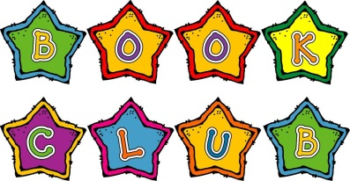

Name ____________________
Toys Go Out
By: Emily Jenkins

Please read the chapters before the meeting, so you are ready to discuss.
Meeting Date | Chapters Discussed
Thursday, October 24th | Chapters 1-2
Thursday, October 31st | Chapters 3-4
Thursday, November 7th | Chapters 5-6

Name ____________________
Toys Go Out
By: Emily Jenkins

Please read the chapters before the meeting, so you are ready to discuss.
Meeting Date | Chapters Discussed
Thursday, October 24th | Chapters 1-2
Thursday, October 31st | Chapters 3-4
Thursday, November 7th | Chapters 5-6

Name ____________________
Toys Go Out
By: Emily Jenkins

Please read the chapters before the meeting, so you are ready to discuss.
Meeting Date | Chapters Discussed
Thursday, October 24th | Chapters 1-2
Thursday, October 31st | Chapters 3-4
Thursday, November 7th | Chapters 5-6

